Research – Issues To Be Addressed

1) Article of Incorporation.

2) Why S-Cooperation?  How fees will be handled by partners. See “**Types of Companies**” section below.

Complying with corporate formalities like bylaws & holding board and shareholders meeting.

* **No time???**

List of board members and shareholders.

* Open discussion???
* See below:
  + Wendell Wilson
  + Lawrence Morgan
  + Rebecca Morgan
  + Comfort Liberty
  + Tellek Liberty
  + Togba Liberty
  + Georgia Godfrey

Recommend Company Structure by the group:

* **Not Yet Decided???**

**Types of Company Partnership Structures**

**URL:** [**https://smallbusiness.findlaw.com/incorporation-and-legal-structures/benefits-and-drawbacks-of-different-types-of-business-entities.html#:~:text=%20%20%20Professional%20Corporation%20%20%20Owners,Partners%20remain%20personally%20liable%20for%20ob%20...%20**](https://smallbusiness.findlaw.com/incorporation-and-legal-structures/benefits-and-drawbacks-of-different-types-of-business-entities.html#:~:text=%20%20%20Professional%20Corporation%20%20%20Owners,Partners%20remain%20personally%20liable%20for%20ob%20...%20)

NOTES FOR TELLEK:

KEY BENEFITS TO TAKE NOTE OFF:

* Regular Corporation Benefits
  + With good accounting, owners and business may be able to pay lower taxes by splitting the business profits among owners – **Verify with Accountant or Lawyer**
  + Owners share profits
  + **NOTE: Please take a look at the disadvantages before approving or considering this type of corporation**
* S Corporation Benefits
  + Owners share profits
  + **Owners share the net business loss???**
  + **NOTE: Please take a look at the disadvantages before approving or considering this type of corporation**
* Professional Corporation Benefits
  + **Owners are not personally liable for the malpractice of other owners – VERY IMPORTANT!!!**
  + **NOTE: Please take a look at the disadvantages before approving or considering this type of corporation**

DETAILED Listing As Described on Website above:

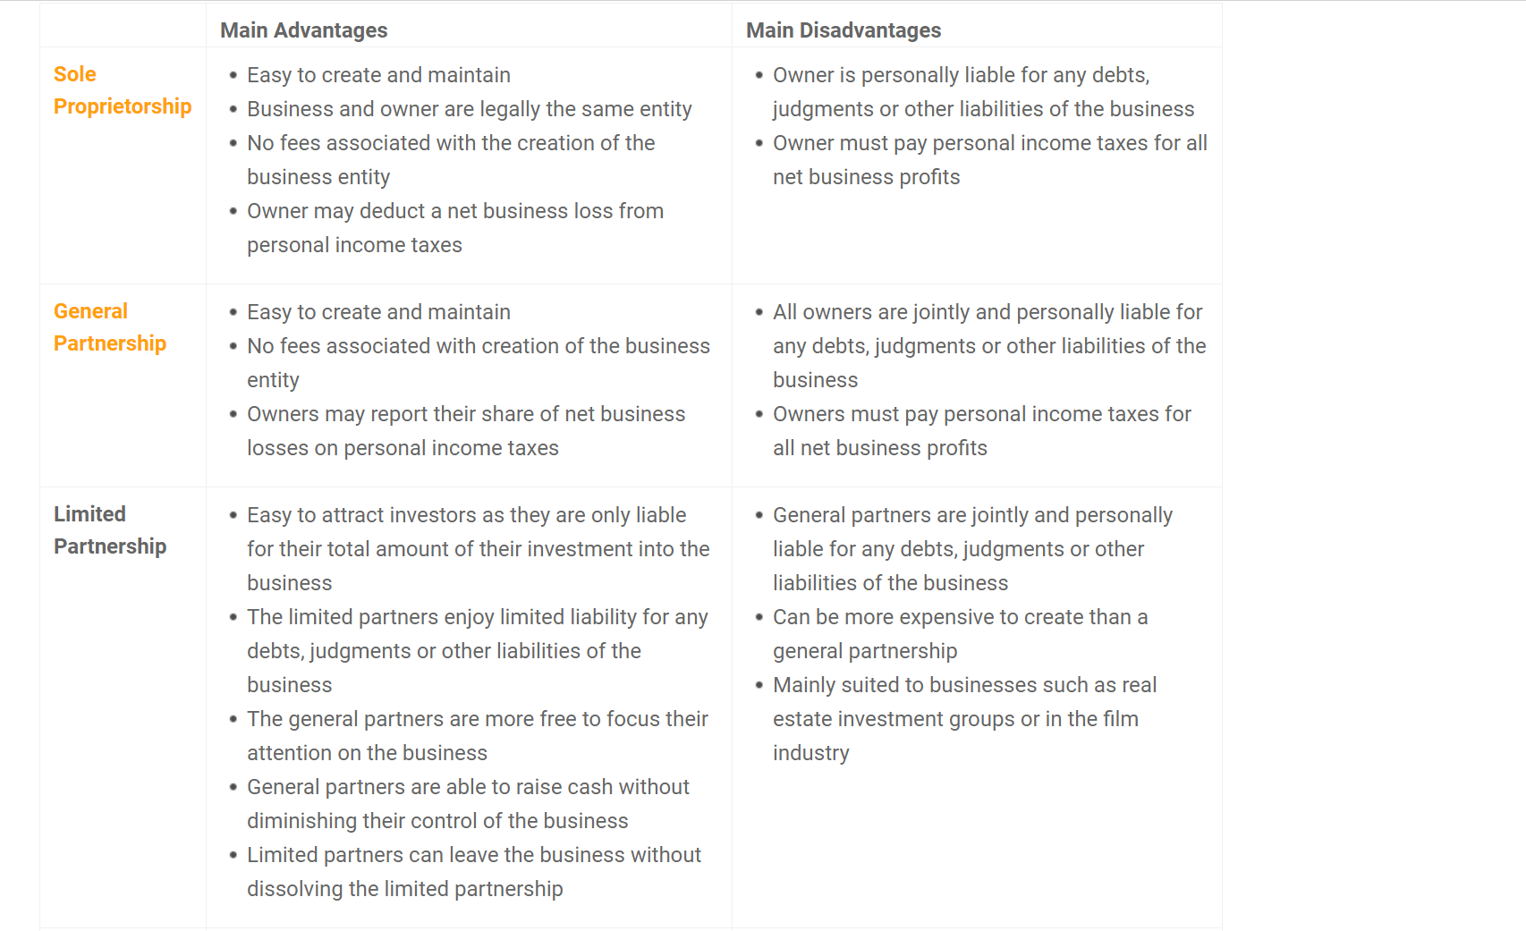

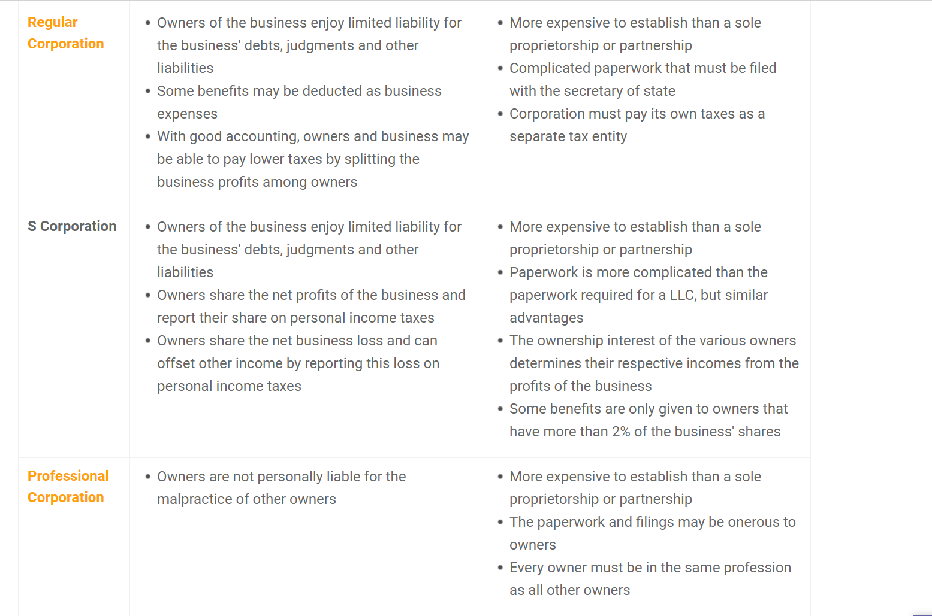

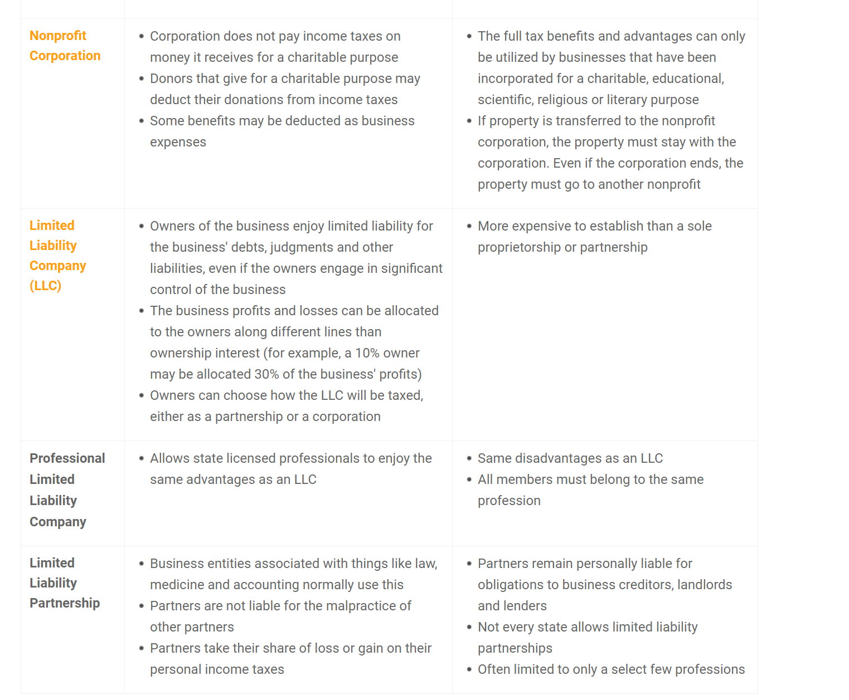

Helpful Links:

- Contracts Attorneys: <https://lawyers.findlaw.com/lawyer/practice/contracts>

- Incorporation Lawyers: <https://lawyers.findlaw.com/lawyer/practice/business-organizations>

- Business Formation Legal Help: <https://smallbusiness.findlaw.com/incorporation-and-legal-structures/legal-help.html>

- Business Formation Resources: <https://smallbusiness.findlaw.com/incorporation-and-legal-structures/resources.html>

- Choosing a Legal Structure: <https://smallbusiness.findlaw.com/incorporation-and-legal-structures/choosing-a-legal-structure.html>

- Corporations: <https://smallbusiness.findlaw.com/incorporation-and-legal-structures/corporations.html>

- LLCs: <https://smallbusiness.findlaw.com/incorporation-and-legal-structures/llcs.html>

- Nonprofit Organizations: <https://smallbusiness.findlaw.com/incorporation-and-legal-structures/non-profit-organizations.html>

- Partnerships: <https://smallbusiness.findlaw.com/incorporation-and-legal-structures/partnerships.html>

- Sole Proprietorships: <https://smallbusiness.findlaw.com/incorporation-and-legal-structures/sole-proprietorships.html>

3) The expectations for maintaining a lawyer. ex. Legal implications of liabilities per ceo/owner/partner.

Terms & Conditions of Partnership. etc.

**Research:**

Fees for maintaining a:

- Lawyers

Determining what kind of Lawyer to hire?

- What services do we need from a Lawyer?

-- Short Term: Getting advises on what company type to select

-- Determining advantages of selecting a domestic or international company type

- What are the fees for the work needed by the Lawyer when specified?

-- Company Setup based on Company Type

4)The expectations for maintaining an accountant. ex. Bookkeeping, Fees and payment etc.

**Research:**

Fees for maintaining a:

- Accountants

What are the fees for the work needed from an Accountant?

-- Bookkeeping???

-- Setup company when company type has been determined

5) The exact construct of the organization and all members.

**Research:**

- The construct of our organization structure and roles or job descriptions have to be carefully defined.

- These members/names below have to have the same or equal or almost equal rights and authority with the listed functionalities of the company

**Names/Members**

--- Wendell Wilson

--- Lawrence Morgan

--- Rebecca Morgan

--- Comfort Liberty

--- Tellek Liberty

--- Togba Liberty

--- Georgia Godfrey

**Managerial Decisions that all members should have the same or equal or almost equal rights on**

--- Contracts Selections

---- What kinds of contracts should be selected

---- Who should work on these contracts

---- Approval of Project Charter, Cost, Estimates, Milestones, Project Plans, .etc

---- **Everything about a contract should have either everyone’s approval??? POSSIBLY, we can word this differently**

--- Marketing Strategies

---- Market Niche Selection

---- What kind of businesses or markets should we target (Federal, State, ????)

--- Financial (Everything that has to do with the financial stability or finances of the company)

---- Accounting (profits, losses, debts, .etc)

---- Accounting Systems or Bookkeeping Systems Selections

--- Selection, removal or research inquiry on Accounting or legal matters

--- Employment when work is more or deciding to hire new people on board

---- Everything about hiring? Who should we contact? Should we hire part-time, full-time, contract, add a new employee? Adding a new employee does not give that person the right or rights of any of the individuals above. All the above names can serve as employees of those positions that are opened if see fit – save cost; if not, person should serve as defined in the job description or role being fill

-- Others???

6) Any miscellaneous that has not been addressed.